Workshop EndNote Basics: exercises continuation from homework
All actions are based on Ms Edge. But If you save your exports everything works the same.
READ ALL INSTRUCTIONS CAREFULLY!
Use the LibGuide EndNote (https://libguides.vu.nl/endnote) for background information and help.

REFERENCES FROM SUBJECT DATABASES (for your academic discipline)
THIS PART REQUIRES SOME CAREFUL READING
In many cases you already know the name of the subject database you are going to use
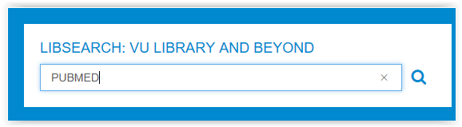
- In that case: use the blue bar form our homepage www.ub.vu.nl
Typ in the name of the source (ENTER) Be as complete as possible. Most often the first hit

- To get a list of recommended subject databases: (your academic field) overview of Subject librarians

- Open your selected database check the publisher
Is it PubMed? Go to d.
Is it published by Proquest? Go to e.
Is it Published by EBSCO? Go to f.
Is it published by another group? Ask teacher

- PUBMED (Medicine)
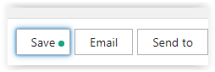
- Go to www.ub.vu.nl and search for PubMed in the LibSearch search bar. Click on Access Online
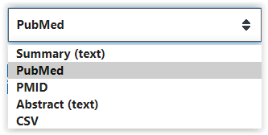
- Perform a search, e.g. tinnitus[mesh] AND 2003[dp]
- Select one or more records or none
- Next: Follow these steps:
- 1. Press SAVE button
- 2. Select what you want to export (selected, al on page, all)
- 3. Output format is PUBMED
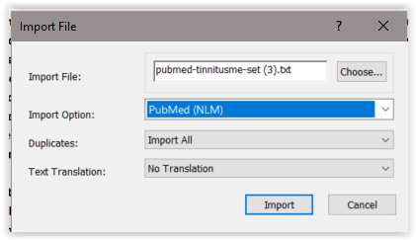
- 4. Create (goes to downloads)
- Repeat the familiar sequence: EndNote top bar: > File > import > click File > Choose
- Select file with your search words. Import format is: PUBMED
- Group your result

You may encounter a database published by PROQUEST:
Names of VU Poquest databases: ARTbibliographies modern; Business dateline; DAAI; British Humanities Index; International bibliography of art; IBSS: Int. bibliography of the social sciences; LLBA; MLA International bibliography; PAO: periodicals archive online; Proquest dissertations & theses

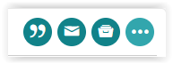
In that case: follow the steps written here.
- Perform a search.
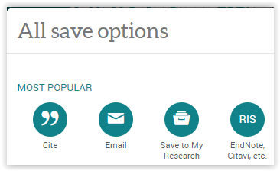
- Mark your desired records or group select them
- (max 100 records = page)
- Press Save (1) > Choose your output format: RIS (2) > Error? Repeat
- Continue (goes to downloads)

- Go to your EndNote Library
- Repeat the familiar sequence: EndNote top bar: > File > Import > Click File > Choose
- Import Option = ProQuest or ‘Reference manager (RIS)’
- If needed unfold list with arrow choose other filters . .
Browse to Proquest
- Press Import
- Group your result

You may encounter a database published by EBSCO:
VU Subscriptions: Business Source Elite; eBook Collection; Regional Business News; Criminal Justice Abstracts; New Testament Abstracts; Old Testament Abstracts; Avery Index to Architectural Periodicals; SPORTDiscus; CINAHL; ATLA Religion Database; Historical Abstracts; Psychology and Behavioral Sciences Collection; APA PsyInfo; PsycARTICLES; Art Index (H.W. Wilson); ERIC ; L'Année philologique

In that case: follow the steps written here.
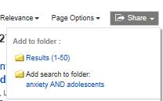
- Perform a search
- Press button Share > 50 per page or selected references
- Look at top bar: Folder
- Select the desired references
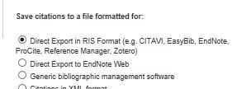
- Press button Export (on the right)
- Choose direct export in RIS format
- Press SAVE (left) (goes to downloads)
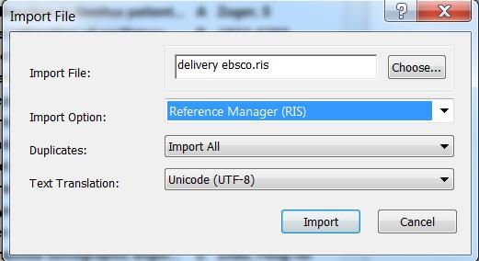
- Repeat the familiar sequence: EndNote top bar: > File > Import > File > Choose the file (delivery)
- Import Option = Reference manager (RIS)
- Press Import
- Group your result

HANDLING FULL TEXT AND PDFs
- Setting your EndNote preferences
- EndNote Top bar: Edit
- Select Preferences (bottom list)
- Check Find Full text. > Do you automatically connect full text to your imported references? (Think of average PDF size)
- How to check your imports?
- Tip: make a group of the references you want to use for your article. Abstracts help you to decide (tab reference in screen on the right)

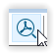
Adding Full Text
Adding PDF with button (fastest)
Once you press the button find full text on the left progress track is listed
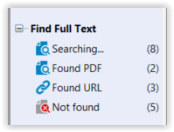
- Select 1 or more references (CTRL-click), or all at once (CTRL-A).
- Click the Find full text button located at the top bar (image)
- The URL becomes visible and the PDF (if found)
- (Note: there are more options)

View the full text
- Select a reference with a connected PDF
- Go to the window on the right of the database
- Click on the Tab ‘Attached PDFs’
- To view the PDF: Press the button as in the image
- Now you can annotate and save notes, print, and mail the PDF
- !! The added PDFs have become part of your library !!

- Adding PDFs manually
- Couldn’t connect a PDF?
- Reason: not all databases contain corresponding PDFs, often only the reference
- Go to the progress screen Find Full Text on the left and
- Select Not found
- Select a reference.
- Go to TAB reference in the screen on the right and make a selection of the title
- Paste in Google Scholar
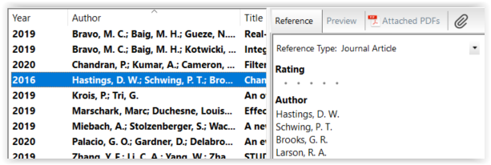
- Is there a link (Libsearch) behind the title? Yes? Click this. NO? Too bad: not within our subscriptions
- Save the PDF on your computer.
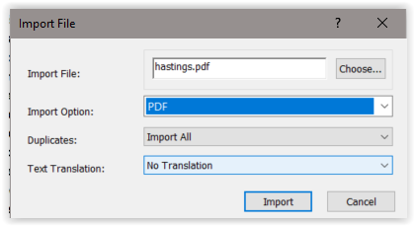
- Right hand Screen: click the Paperclip Button (red circle)
- Browse to the PDF and click Open
- The PDF is connected

- A group of PDFs:
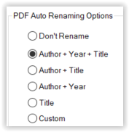
- If you have saved PDFs prior to this course, do the following
- 1st Set your preferences: Top bar Edit > preferences > PDF handling
- Choose: author year title. Now in many cases the PDF shows these data, or else have to do it manually
- Top Bar > File > Import > Folder >
- Browse to the folder and select
- Import option is arranged to PDF

- ENDNOTE AND WORD

Citing in Word
Click in Word on the Tab EndNote on top of the screen to see the citation options.

Citation in text using the search menu:
- Click where you want to insert your citation
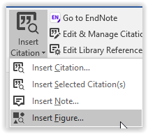
- Select from menu Insert Citation: Insert Citation
- Search for a reference by author, or title etc.
- From the menu select ‘insert’

- Citation in text from a selected reference:
- Click where you want to insert your citation
- Select a reference in Endnote
- Select from menu Insert Citation: insert selected citation
- Insert your selected reference

- Adding references to footnotes:
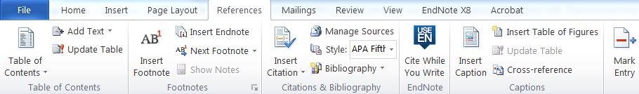
- Place your cursor, where you want to insert the footnote.
- Create a footnote from Word from tab References (or tab Verwijzingen)
- a note number appears at the bottom of the page
- Use EndNote Menu Insert Citation
- Your note is placed inside a Footnote (and also as an EndNote)

- ENDNOTE IS DYNAMIC / Sharing your references
Wherever you write and cite, EndNote will adjust your citation numbering and references.
Adding citations while you write you create a literature list at the bottom of your document.

Remove coding in Word
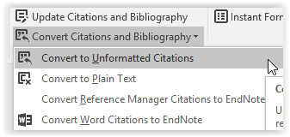
- Go to the end of your document to the references list. Click on the list and see that it highlights. That’s the connection to your EndNote library.
- Go to the EndNote TAB in WORD:
Convert Citations and bibliography and choose
‘Convert to plain text’.

Sharing references From EndNote
If you have your article references in a separate Group:
Select the references
Either Copy (keeps connection with EndNote) or Copy Formatted (removes connection with EndNote)

Note: there are many more options to share.

Output styles in Word
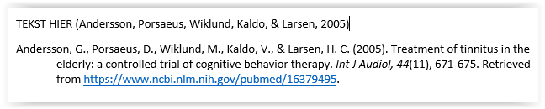
You can easily change your output style in the EndNote Menu. Just click on the arrow to search for your preferred style. Common styles are APA 6th or Vancouver.
Note: not all possibilities of EndNote are dealt with in this course. More exceptional and special methods can be found at the forum of www.endnote.com or in youtube

EXTRA ACTIONS REVIEW EN ONLINE CERTIFICATE
REVIEW
- http://tinyurl.com/y9rn6vuh

ONLINE CERTIFICATE : EDUBADGE
Go to https://pilot.eduid.nl/portal/register
Sign up here
Confirm the email (within 12 hrs)
Set a password
Log on to eduID with email and password
Connect your edu account to VU in security settings > choose Surfconext > select VU
Now you can apply for badges
(log in with eduID at edubadge, not surf)
Request your badge: https://pilot.edubadges.nl/public/badges/4wxMZUWIStSgPNPfaTRS6Q
(consent)

CONTACT
Questions:
M: vraag.ub@vu.nl; M: r.e.vermunt@vu.nl; LibGuide EndNote: libguides.vu.nl/endnote

